N E W S L E T T E R
BLUEBIRD CARE
Lancaster & South Lakeland
Summer is here and my gladioli are just about to flower. I love spotting those spears pierce through the soil from March and confidently thrust their way up and up. They seem so sure of themselves.

Welcome to the team!
I’d love to introduce our new Supervisor Niamh Whiteside.
Niamh has joined the rest of our Supervisory team and is making a great impact already! She will be heading out and about over the next few weeks to get to know all of you, I’m sure you’ll like her just as much as we do!

Coffee Morning – save the date

We cordially invite you to a coffee morning/afternoon at our home here in Willow Mill, Caton on September 21.
Plenty of space for relaxing and comfortable seating.
Friends and family also welcome
Yummy refreshments
Free pick up and drop off service for those who need it.

News
Unfortunately, we start this newsletter on a sad note. Our Care manager, Jen Smith, who started in early May has departed. A new opportunity in supported housing became available to Jen that she could not refuse. In such a short time Jen brought in many improvements to our administrative processes. The team here are all sad to see her go. But adversity is to be overcome if we are to thrive and so we go on. We are already on the hunt for Jen’s replacement and I can tell you all with absolute confidence that we very much business as usual.

I also want you all to know that I love what we do here and I care enormously about the people we serve – customers, staff and their families. Pretty much nothing can dint my optimism in our success nor my commitment to your well-being. We have many carers who are excellent at their job and we have a strong set of effective and compassionate officers who know how to organise and administer our service. Please be assured, all will be well

In the meantime, I have installed a temporary structure which I personally shall lead until we have Jen’s replacement on board. Most significantly, Alyson Hartlebury will be the Acting Manager (supported closely by myself). Alyson joined us as a carer in October 2021 where she quickly moved to Senior Carer and earlier this year to Quality and Compliance Manager. Alyson has undertaken Management courses and gained all practical training qualifications and experience. I have every confidence in Alyson’s judgement and commitment to her Duty of Care.

Values
We spent some time recently reflecting on what motivates us in our work. Even though we love what we do, there are so many risks and hazards in organising a home care service that the intensity of it can be challenging to cope with at times. We realised that it was the values we hold that really counted and that so long as we work in support of those values we know we are doing well at our job, whatever the circumstances. When we do not heed our values, our performance drops. So between us, we came to a set of values and I wish to share them with you. If your experience is that we do not demonstrate these truthfully in our service to you, then please let us know. We do not always get it right, of that I am well aware. But I can promise you that if you tell me about it, I will act to remedy it insofar as we can.
KINDNESS COMMITMENT INTEGRITY ACCOUNTABILITY POSITIVITY TEAMWORK HONESTY
SENSE OF FUN TIMEKEEPING HUMILITY

Customer Survey

Earlier this year I sent out our annual Customer Survey. Thank you to all those who responded. I attach a report to this newsletter. In essence, what you told us was that
we retain a good reputation in the community for being: friendly staff; happy; professional; caring; well-trained; responsive; excellent; intelligent; personal service. You said we give you the visits you want at the right time and that our carers always treat you with dignity and respect.
In terms of how where we can improve, you told us:

- You are not all satisfied, up-to-date and familiar with your care plans and a number of you do not know how to complain about us if you need to
- We are not meeting our own standards when it comes to informing you about last minute rota changes
- Our communication and consistency of service could be better for some of you

Feedback like this is of great value to us. We have discussed these results internally and agreed an action plan. Firstly, we will provide additional training on communication and responsiveness for our office based team. On rota changes, our standard is to always inform customers when time changes are made after the rota goes out (this is almost always due to management of staff sickness absences). So we will conduct regular weekly audits of our performance on this. On care plans, we have stepped up our programme of ensuring ALL care plans are fully up-to-date. We will then leave paper copies of those in a yellow folder in customer homes. These folders will contain written reminders about our service. We will seek customer feedback on our performance again before end of October, to identify improvements made

Achievements.
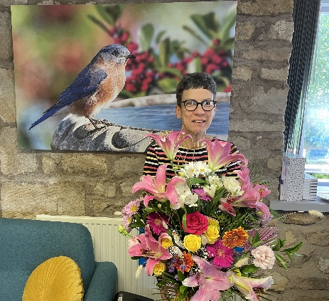
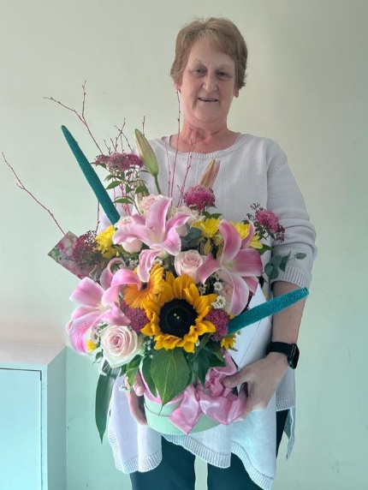
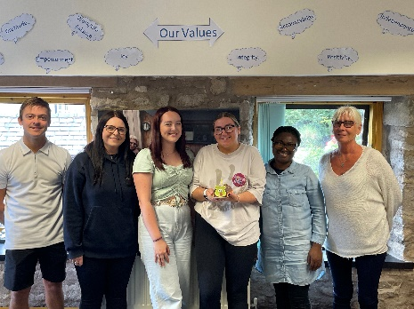
We have some fantastic staff, as you know. Society does not always appreciate the value of carers but I know from personal experience what a huge difference compassion and care make to a person’s quality of life. So we
celebrate those things, with BIG TREATS
