-
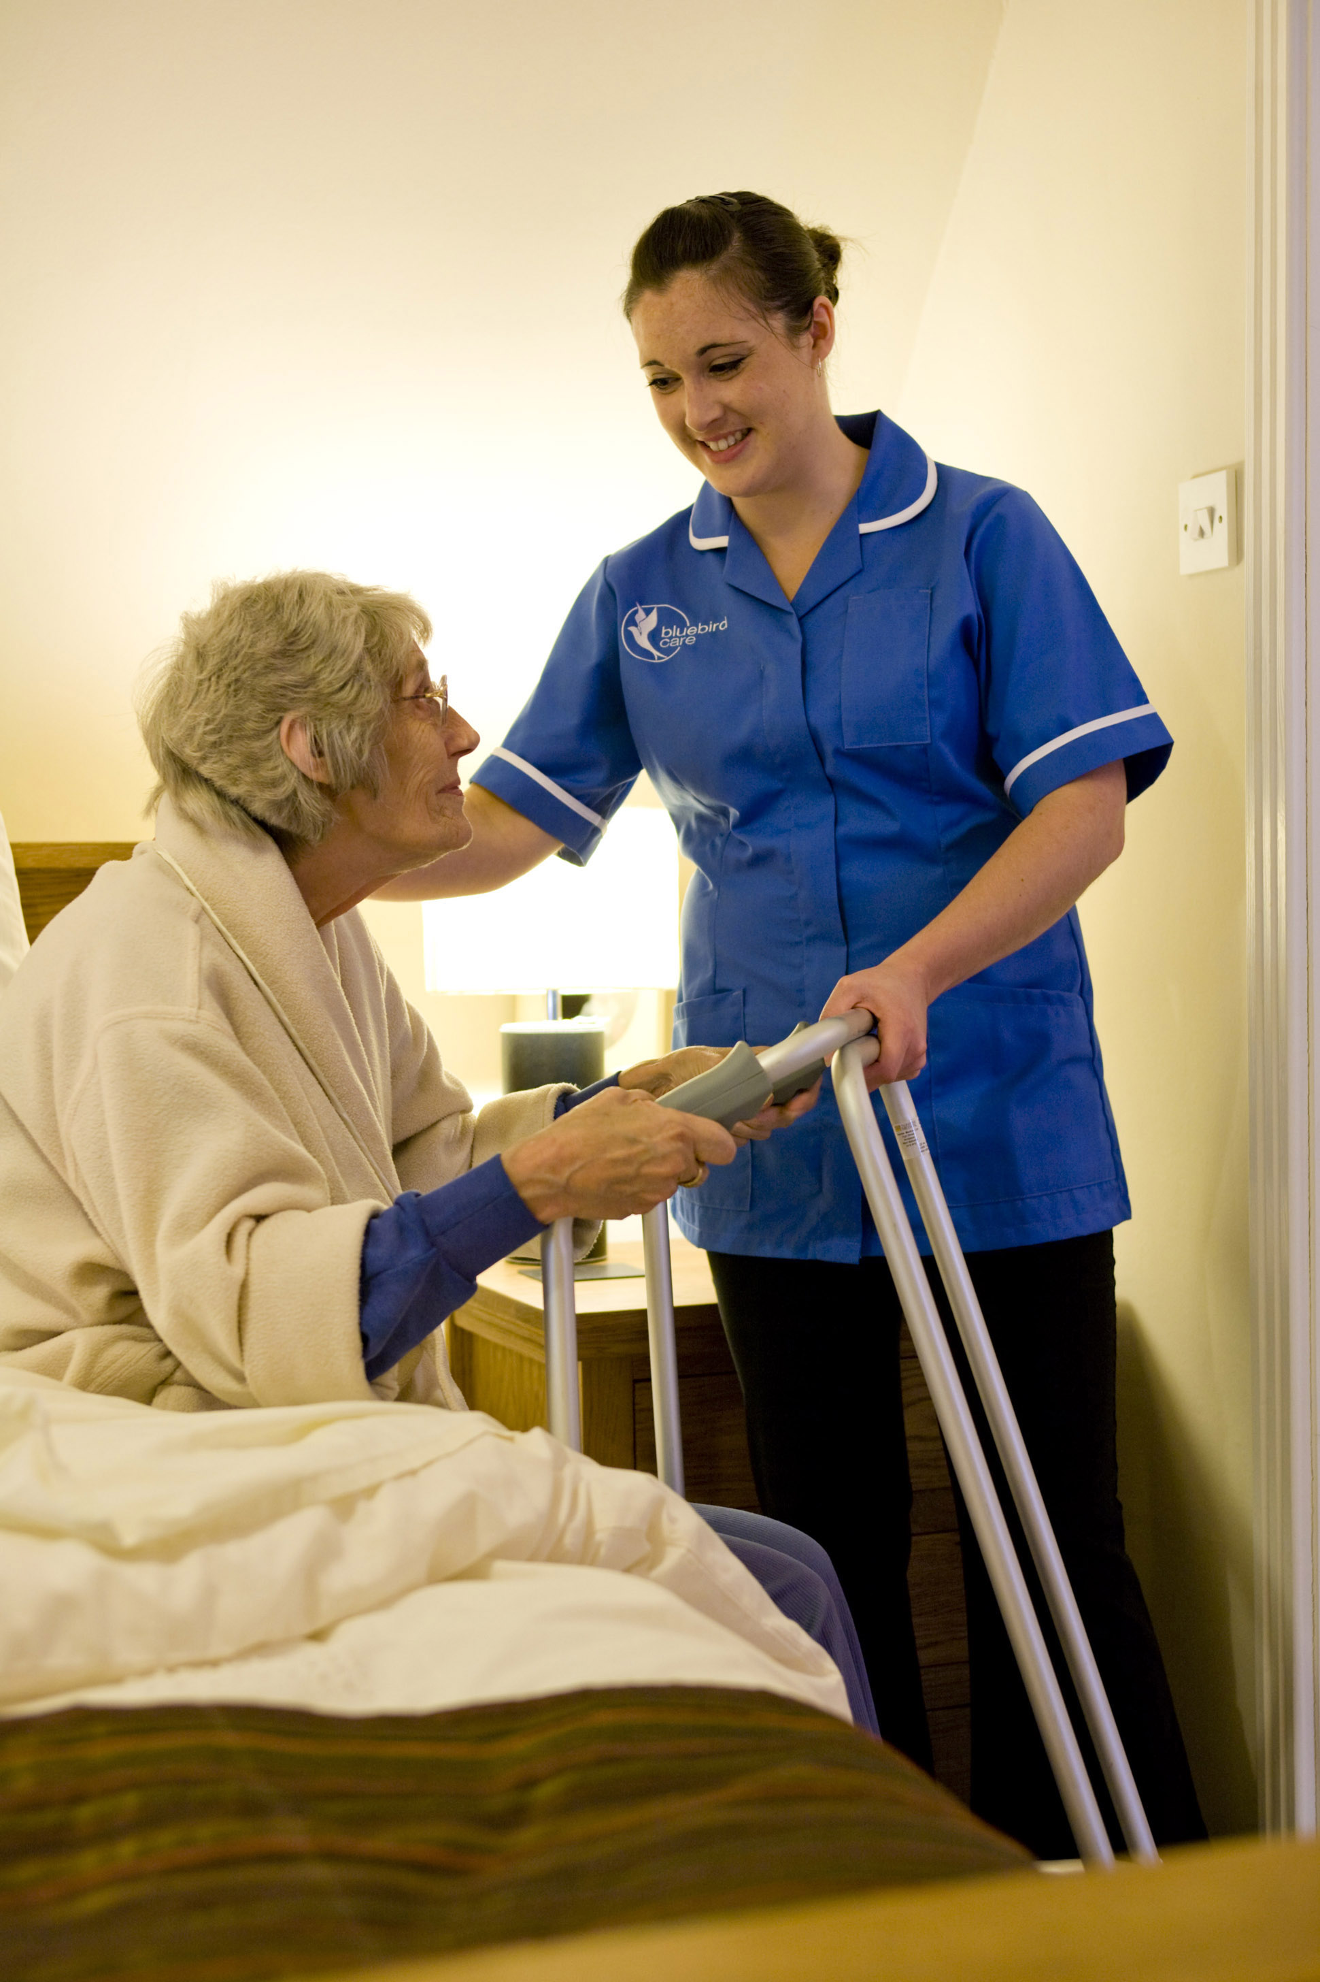

We Care Passionately


WELCOME TO
BLUEBIRD CARE

Information and guidance

This information has been designed with you in mind, so you and perhaps your family will be able to make an informed decision on which of our services are right for you.

At some time in our lives we will probably find ourselves needing a little extra help with daily tasks. Or we may be looking after a loved one, whether they are our parents, sisters, brothers, uncles and aunts or close friends, we will want to do our utmost to give them the best help and care possible.

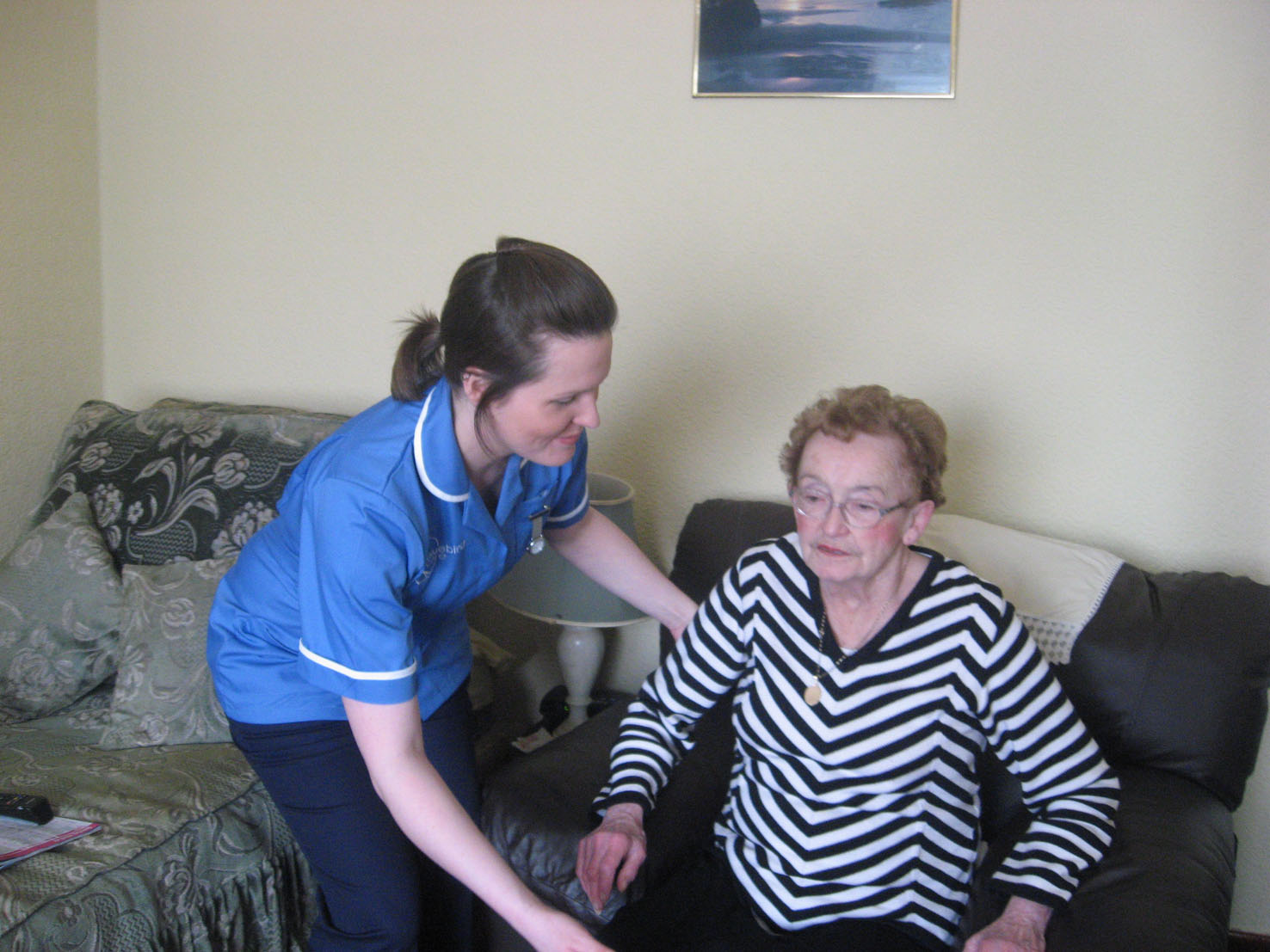

At Bluebird Care, we understand that it is not always possible to take on the role of full-time carer for your loved one as we all have work and family commitments of our own. Caring for a loved one when we are close by is hard enough but when we are separated by distance this becomes even more difficult.

Bluebird Care offers a full range of home care services to assist and support families and individuals in their own homes. Bluebird Care provides a professional, highly trained team of carers. All staff, from the management and administration team to our carers, believe passionately in supporting and delivering quality care with dignity and in a polite manner and we work hard to ensure our values are upheld at all times.

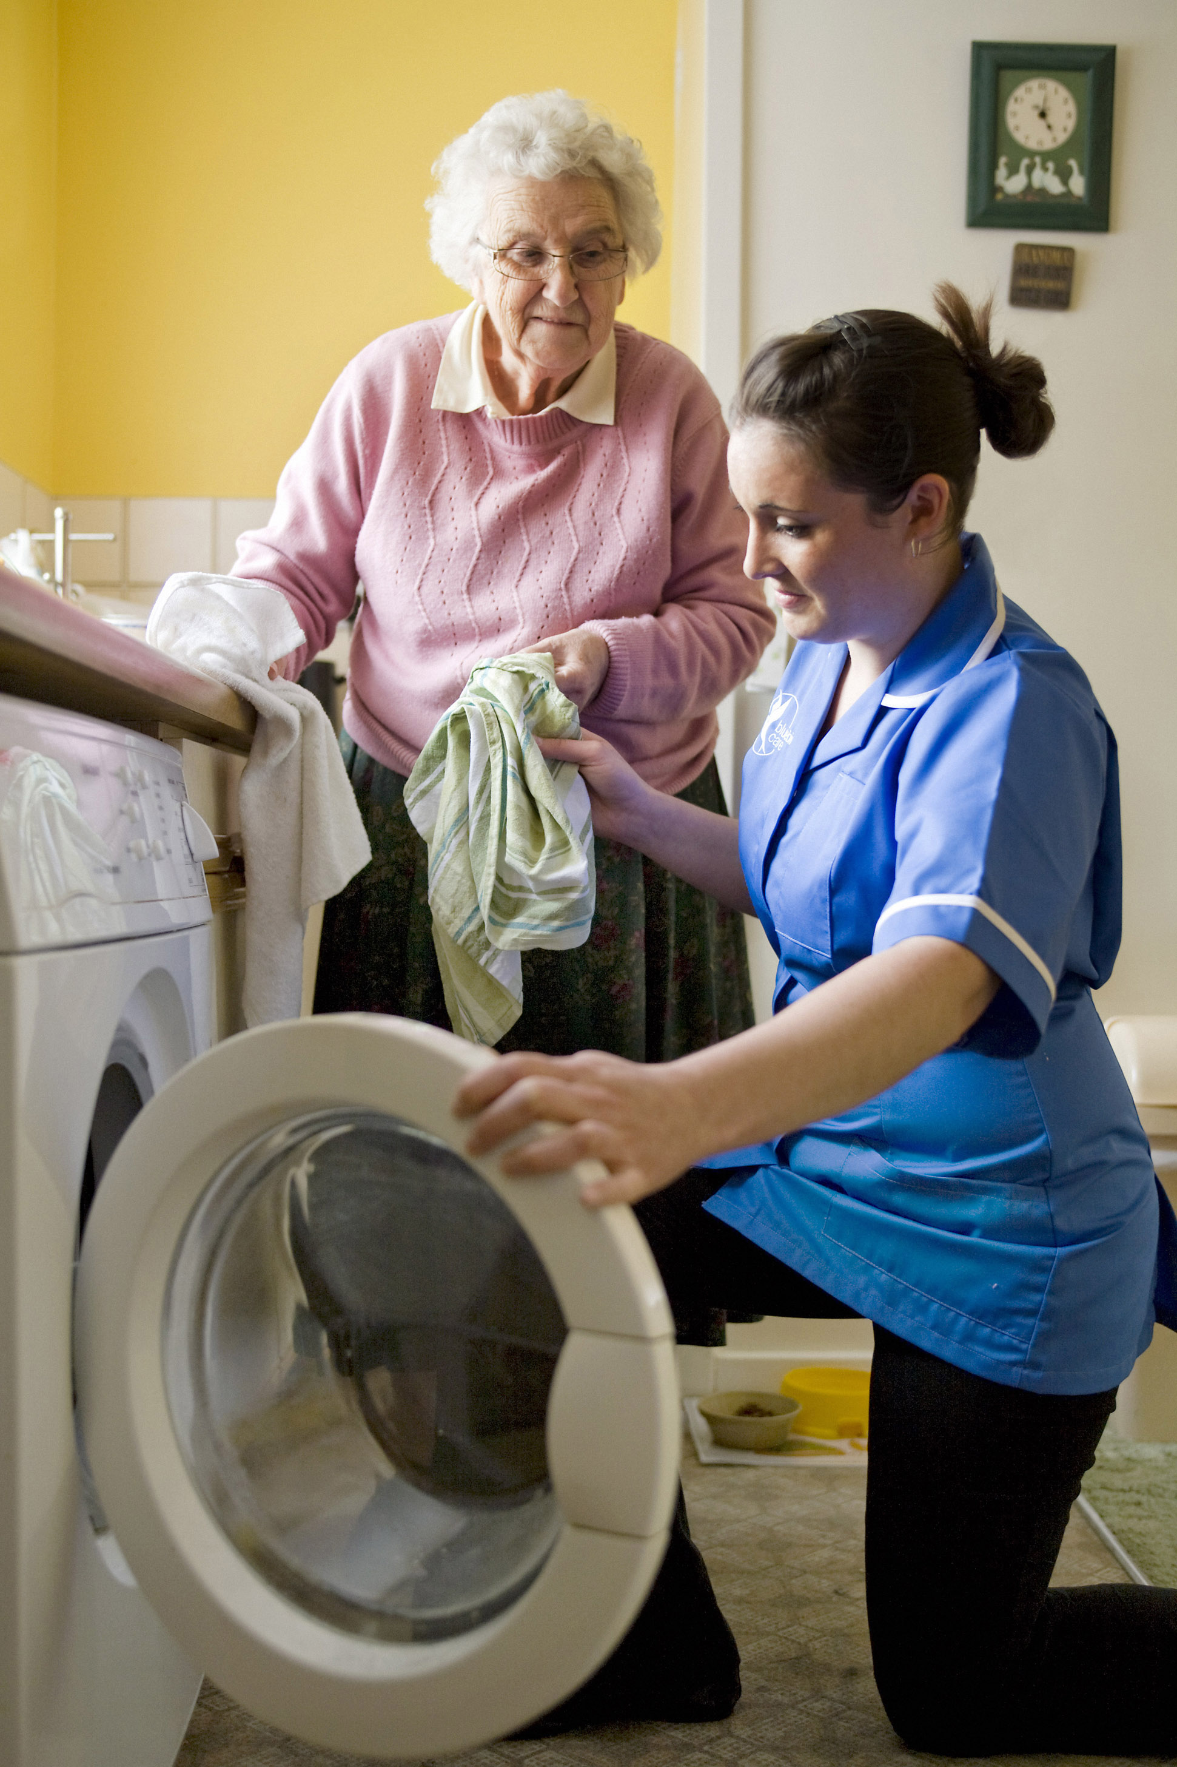

By working together with our customers, Bluebird Care consistently delivers a professional quality service, that is flexible and responsive to individual needs, providing ‘what the customer wants’, ‘when they want it’ and with the respect and dignity all customers deserve.

Please feel free to contact our Mid Staffs office where a Care Supervisor will be happy to meet with you, your family and any other health professionals who may be involved, to discuss your care needs further.

Telephone 01543 505 262
Please note: All incoming and outgoing calls are recorded for training and monitoring purposes.

STEP BY STEP GUIDE TO HOME CARE

Step 1. Initial visit & Assessment

When you have made your initial enquiry to us, our Care Supervisor will arrange a complimentary, no obligation meeting with you and your family to discuss your loved one’s care needs further. This initial meeting can be carried out in the home or hospital. Our Supervisor will advise and guide you on what level of care may be required to meet your needs and will also explain how we work, about our carers and the tasks and activities they could carry out. Family members and other healthcare professionals may discuss any concerns they may have at this visit.

Step 2. Personalised individual Care Plan

After the initial meeting, our Care Supervisor will devise an individual, personalised Care Plan for you or your loved one. The Care Plan will include all the information gathered and will include direct instruction for the carer to follow to ensure all care needs discussed are carried out to your satisfaction. Our Supervisor will then appoint the most suitable carer(s) for you.

Step 3. Customer/carer introduction

Once the Care Plan has been finalised to your satisfaction and a start date agreed, it’s now time to introduce your carer. We always try to accompany the carer on their first visit to you. This part of our service to our customers is a way of putting you and your family at ease and making sure you are happy with your carer.

Step 4. Quality Assurance

We believe that monitoring and supervision of our carers is of vital importance to your care running smoothly. Our Care Supervisor will visit you occasionally whilst the carer is in your home during the initial ‘settling in’ period. Thereafter, we will keep in regular contact

to ensure the carer is carrying out their duties as set out in the Care Plan and you are satisfied with the level of support you are receiving. If you are not satisfied with any aspect of our service, you can contact us at anytime. We also carry out regular customer satisfaction surveys to help us identify any issues and resolve them.



Step 5. Customer Reviews

The carer has been with you or your loved one for some time now but it is becoming clear that your needs are changing. There may also be other activities you would like to add to the Care Plan. You may feel that you or your loved one needs more or less care than originally planned for; this is where our Customer Reviews come in. Our Care Supervisor will liaise with you and/or your family on a regular basis for the first 12 weeks and then as required thereafter to ensure that any changes needed are made to the Care Plan and everyone is advised accordingly.

OUR CARERS

Carers

Bluebird Care attracts and recruits the friendliest and most reliable carers. We believe that in order to provide the highest standard of care possible for our customers, our carers must also be of the highest standard. We only employ people that we personally would be happy to have looking after our own loved ones. We also believe in taking good care of our carers, they are trained to the highest possible standard, monitored regularly and above all listened to if they have any issues. We go out of our way to promote a positive, happy and supportive environment for our carers to work in.

Recruitment

Our carers undergo a rigorous interview, recruitment and selection process. This ensures that we only employ the best carers possible. It is a fact that we turn down far more applicants than we employ which is the opposite to most care providers. Our carers undergo enhanced Criminal Records Bureau vetting and we check and verify recent employment history and collect a minimum of two written references.

Our carers are not agency staff and are all directly employed by us. They are all proficient drivers and fully insured to transport you to appointments and outside activities. They wear uniforms, and carry Bluebird Care photo identification badges at all times whilst on duty.

Training

Our carers undergo an intensive induction training course when they join Bluebird Care. Induction & Orientation days take place in-house and include:
- Infection Control
- Medication
- Food Hygiene & preparation
- Personal care skills
- Abuse Prevention training
- Health and Safety/First Aid training
- Bluebird Care Policies & Procedures

Further specialised training is provided to improve our carers’ knowledge and understanding of our customers’

needs. We provide ‘in house’ specialised Moving & Handling training.

All of our carers must attend our training courses regardless of whether they have done this type of training in the past. When we are satisfied that their level of knowledge is good enough, they will then ‘shadow’ an experienced carer(s) for a period of time. Once this has been satisfactorily completed they are then allowed to work in our customers’ homes.

Quality Assurance

Our carers are supervised very closely. Their performance is constantly monitored through a combination of supervisor/manager visits, telephone calls and meetings. We also conduct regular progress meetings and appraisals with our carers.



We hold regular carers’ team meetings where carers can get together with our Care Manager on an informal basis and discuss any issues they may have.

We strongly believe that if our carers are happy working for Bluebird Care that they will deliver the best level of care possible to you.

Please feel free to contact our Mid Staffs office where one of our Care Supervisors will be happy to meet with you, your family and any other health professionals who may be involved, to discuss your care needs further.

Telephone 01543 505 262

Bluebird Care Services

The Care Plan

Each customer will have a Care Plan that is personally tailored to suit them and their circumstances. The level of help will undoubtedly adjust as time goes by, as the customer decides to expand or change the range and type of services that are most appropriate or desired. Here are just some of the services that Bluebird Care offer.

Daily Essentials

- Companionship/Conversation/Reading
- Preparing meals and light snacks
- Prompting or assisting with medication
- Assisting with clothing selection
- Monitoring meal requirements and storage
- Help with shopping including collection
- Organise post and assist with correspondence and diaries
- Arrange Visits and Appointments
- Provide transport for hospital or doctor’s appointments
- Accompany you on trips out or even holidays
- Overnight care (awake or on-call)
- Comfort Calls (a telephone call for a chit chat to reminder to have a hot meal. This can be tailored to customer’s needs. From 15 minuets.

Around the House

- Light housekeeping
(dusting, mopping and vacuuming etc.)
- Laundry & ironing
- Make beds and change linen
- Prepare Shopping lists
- Take out rubbish

Please feel free to contact our Mid Staffs office where one of our Care Supervisors will be happy to meet with you, your family and any other health professionals who may be involved, to discuss your care needs further.

Telephone 01543 505 262

Personal Care
- Help with getting up and going to bed
- Bathing & showering
- Assisting with mobility
- Continence care
- Special diet/meal preparation
- Assistance with feeding
- Transferring and positioning
- Dressing

Specialised Care

We have carers with different levels of knowledge about assisting people with these difficult conditions. We will endeavour to ‘match’ the right carer for your needs. Where further knowledge and training would be beneficial, we will arrange for this to be undertaken.
- Learning Disabilities Support
- Alzheimer’s & Dementia Care
- Parkinson’s Care
- Diabetic Care
- Assistance with Physiotherapy
- Assistance with speech therapy



LIVE-IN CARE

Live-in Care

Live-in care is a realistic affordable service for you or your loved one as an alternative to residential care. Our live-in care service will provide you and your family with peace of mind and security by having a Bluebird Care Personal Assistant living in your home with you on an ongoing basis.

These days more and more people would prefer to live out their lives in their own homes and if their care needs are low to moderate then this is a perfect solution. You or your loved one will be able to keep your independence and routine, and be surrounded by your own friends, family and pets.

Your Personal Assistant will be able to adapt and attend to your changing needs without too much disruption to you or your family. You will all have peace of mind knowing that your personal assistant is on hand when you need them.

Can anyone have a live-in carer?

Of course, anyone can avail of this service, however it is suited best to people with low to medium care needs who may need ongoing assistance and support at home. People who would benefit from a Personal Assistant would be someone who may live on their own or who has limited family support. They may have

- Alzheimer’s Disease
- Parkinson’s Disease
- Multiple Sclerosis
- Cancer
- Motor Neurone Disease

Every person’s personal circumstances are taken into account when deciding whether live-in care is appropriate.

How do I get a live-in carer?

It works in the same principal as setting up any care package, except the Care Plan is more detailed and tailored in a slightly different way to ensure that you or your loved one receives the best possible support, allowing for ongoing changes in care & social needs.



Good Live-in carers often prove extremely difficult to find and recruit. At Bluebird Care we will always use our considerable resources to try and locate a carer that will be a good match for you but this may involve a wait of several weeks or months. During this period we can generally provide adequate hourly care to satisfy both your requirements and your budget.

Please feel free to contact our Mid Staffs office where one of our Care Supervisors will be happy to meet with you, your family and any other health professionals who may be involved, to discuss your care needs further.

Telephone 01543 505 262

LIVING WITH
ALZHEIMERS DISEASE & OTHER FORMS OF DEMENTIA

Caring for a person you love with this disease at home can be demanding, lonely and challenging. Symptoms grow worse over time, and there’s no way to predict how quickly the disease will progress or exactly how behaviour will change. Managing basic activities of daily living such as eating, talking, sleeping, dressing and finding things to do can be hard for both your loved one, you and your family, especially as the disease becomes more severe.

You & your family need support too

Finding out that your loved one has this disease can be shocking, stressful, frightening and overwhelming. As you begin to take stock of the situation, here are some tips that may help.

- Ask your doctor any questions you may have about the disease and what support networks there are locally
- Find out what treatments might work best to alleviate symptoms or address behaviour problems
- Talk to people who have been placed in a similar situation as they will be able to give you valuable insights and advice
- Contact the Alzheimer’s Society for excellent advice, guidance and information
- Plan for your future, understand that you and your family will need help and support
- Understand that you will need help to look after yourself as well as your loved one

Bluebird Care can help you

You and your family are the primary care givers for your loved one. However, our carers can provide you with much needed assistance and support when, where and how you need it.

- Assistance with personal care
- Respite care to give family care-givers an important break
- Assistance with meal preparation and feeding
- Assistance with getting up & going to bed
- Overnight care
- Companionship for your family and loved one
- Assistance with physical and social activities
- Medication administration

Our carers are trained to deliver all aspects of care in a professional, dignified and safe manner to our customers in their own homes. We also offer a wide variety of dementia care training to our carers on an ongoing basis.



Please call our Care Supervisors to arrange an informal no obligation visit. They can discuss all your care requirements and put together an individual Care Plan for your loved one and to ensure all the family needs are met.

Telephone 01543 505 262
FREQUENTLY ASKED QUESTIONS

What is Home Care?
Home care provides individuals with one-on-one assistance and support in the comfort of their own home. This enables them to live at home independently, safely, with dignity and privacy.

How much does home care cost?
Bluebird Care charge a rate per visit for our home care service. Visits can range from 15 minutes right up to several hours a day or overnight. Rates and costs will be discussed and agreed upon with the customer during their initial visit with our Care Supervisor. We have a transparent price policy; there are no hidden booking fees, mileage payments (except for customer trips) or VAT. The price we quote is the price you pay.

Can I get help with the costs of care?
Many of our customers are eligible to receive financial assistance with their care costs from Social Services. This will depend on whether your combined savings/capital falls below the current Government threshold. You can check with your local Social Services department who may carry out an assessment with you. If you are eligible, Social Services will normally arrange your care through their ‘contracted’ providers. You may prefer to choose your own provider. This can be done in several ways but the usual way is through a scheme known as Direct Payments. This scheme gives you the right to choose your preferred care provider, thereby allowing you more choice and control. Providing you are eligible for help from Social Services and are able to make decisions or express preferences about the services you receive, you have the right to receive a Direct Payment. Telephone your local Social Services department for further information and to check your eligibility.

Do I have to have any minimum hours?
No, you do not have to have any minimum number of hours with Bluebird Care, we believe it is everyone’s right to choose the amount of care they wish to have, anything from one 30 minute visit a week up to full time live-in care.

Why should I stay at home & have a carer rather than go into residential care?

We all enjoy the comforts of our own home and garden, with our friends, family, pets and treasured possessions around us. Familiar surroundings are a vital part of our wellbeing and health. Having a carer coming into your home ensures that your family stays together and it promotes healing if someone has recently come out of hospital. Home care also allows people to have freedom, choice and independence.

Do I have to commit to a long term contract?
No, we have terms of business like every other company providing a service; however, you are free to cancel your care service with just 28 days notice (shorter by prior arrangement). You are also entitled to cancel within the first seven days with no notice requirement if you decide to.

Is care at home cheaper than residential care?
The price of home care generally works out more economical than residential/nursing home prices. Home care is charged by the visit and not a set weekly rate so you retain flexibility and control over costs. You will also be able to carry on enjoying your home comforts, freedom and independence.



How do I know I can trust Bluebird Care carers?
Bluebird Care carers are trained in all aspects of personal care and grooming, companionship, continence care, moving & handling, infection control, health & safety, food hygiene and dementia care. Our carers either have an NVQ Level 2 in Social Care (or its equivalent) or are working towards it.

Our carers go through a rigorous recruitment process. All previous employment is checked, and every carer is employed subject to Criminal Records Bureau vetting before they work with any of our customers.

Bluebird Care is committed to the highest standards of service. We monitor, supervise, train and appraise our carers on a constant basis.

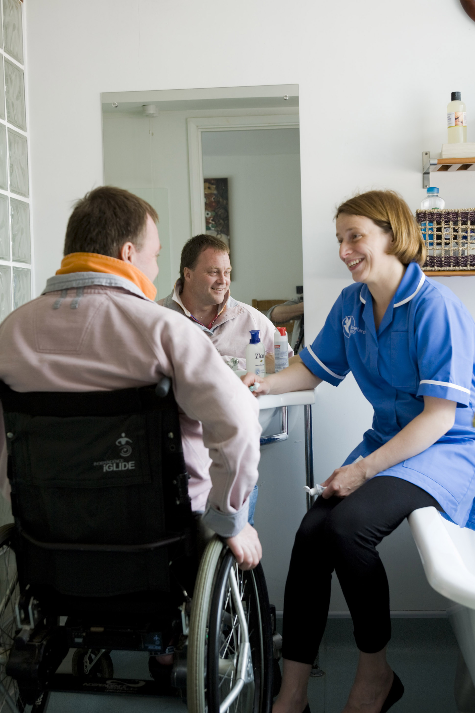

Who owns, manages and runs Bluebird Care (Mid Staffs)?

Bluebird Care (Mid Staffs) is owned and operated by Lifestyle Support Ltd under licence from Bluebird Care Franchises Ltd and is fully registered with the Care Quality Commission. Bluebird Care (Mid Staffs) opened in April 2007 and prides itself on a friendly family feel. The offices are located in Bermar House, Rumer Hill Road, Cannock. The service provides care throughout the local area including: Cannock, Rugeley, Great Wyrley, Penkridge, and all surrounding areas. In addition to traditional care visits we can also provide carers for sleep-ins and live-in care if required.

The team of directors consisting of John & Susan Milakovic and Allen Willey are actively involved in the running of the service and are passionate about ensuring customers receive the highest standard of service.

Allen is also the registered care manager and is responsible for ensuring the safe and effective delivery of high quality care to customers through recruitment, training, supervision and monitoring of the care team. Allen also ensures that the quality control systems are effectively operated and developed.

All of the Senior Management Team have an excellent knowledge of the requirements of the Care Standards regulations and possess strong leadership and management skills. They also take great pride in providing a first class service to their customers. They are backed up by the support provided from Bluebird Care’s support team in Petersfield, Hampshire.

Care services are delivered by our exceptional care team who uphold the values of the company in the way they deliver care. The team of carers is supported by a dedicated office team of supervisors, co-ordinators & trainers.

Only very special individuals are accepted as employees of Bluebird Care and the team in the Cannock office takes enormous pride in the service they deliver to customers.

The company owns & operates two Bluebird Care offices based in Cannock and Codsall and are part of a national network of 200 Bluebird Care offices nationwide.

Please call our Care Supervisors to arrange an informal no obligation visit. They can discuss all your care requirements and put together an individual Care Plan for you or your loved one and to ensure all the family needs are met.

Telephone 01543 505 262

Bluebird Care (Mid Staffs/South Staffs)

Price List – Applicable from 10th April 2023
- Prices are exempt from VAT and include traveling time. Mileage charge for shopping trips, hospital appointments etc is 0.50p per mile or part thereof. Please Note – we do not charge our customers a booking fee.
- Plase see overleaf for our Terms of Business
Visit Length | Price
WEEKDAYS 6am-10pm
(Minimum visit time is 30 mins)

One Hour | 34.00
45 Minutes | 27.00
30 Minutes | 23.00
Sleep-in (10.00pm – 06.00am)*  Prices Start from | 180
WEEKENDS 6am-10pm
(Minimum visit time is 30 mins)

One Hour | 38.00
45 Minutes | 32.00
30 Minutes | 28.00
Sleep-in (10.00pm–06.00am)*  Prices Start from | 180
Bank Holidays 6am-10pm
(Minimum visit time is 30 mins)

One Hour | 40.00
45 Minutes | 33.00
30 Minutes | 30.00
Sleep-in (10.00pm – 06.00am)*  Prices Start from | 180
Live-in Care:
Standard or High Dependency Needs -
Please call for details & free quotation

Short-term live-in care is charged at standard hourly rates

*Note: Waking nights (classified as more than two 20 minute assistance periods per night) are charged at the prevailing hourly rates.



Please feel free to contact our Mid Staffs office where one of our Care Supervisors will be happy to meet with you, your family and any other health professionals who may be involved, to discuss your care needs further.

Telephone 01543 505 262

TERMS OF BUSINESS FOR PUBLIC BODIES, CUSTOMERS AND PURCHASERS

- These are the main terms of business for Lifestyle Support Limited trading as Bluebird Care (Mid & South Staffs) hereinafter known as Bluebird Care (Mid & South Staffs). Other considerations will revolve around our legal responsibilities and the policies and procedures of the company, which are available upon request and which may vary from time to time. All work is undertaken subject to the then current Terms of Business of the company. Purchasers and users of the service will be deemed to have accepted these terms by accepting care services from Bluebird Care (Mid & South Staffs).

- Bluebird Care is a registered provider of domiciliary and live-in care services

- All Care Workers are under contract with Bluebird Care for the provision of care services.

- Bluebird Care will give a minimum of fourteen days’ notice of any change in the fees payable. A retainer fee of 50% is payable for respite or hospital stays up to 14 days, after which the allocated call times may be reallocated.

- Bluebird Care will provide a detailed invoice or breakdown for each customer. Invoices are payable within seven days. If invoices are not paid this may affect the ability of the company to pay care workers and hence service may be suspended if accounts are not paid promptly.

- The customer has the right to terminate this agreement within fourteen days of signing this agreement. Should this be the case all charges for any services which have been delivered prior to any such termination shall be chargeable and payable at the agreed rate. Any termination within the first fourteen days shall not be subject to a notice period and will be immediate.

- Should a customer or their representative chose to appoint a care worker introduced to them by Bluebird Care as a direct employee or a self-employed person, Bluebird Care shall levy an invoice of £1000 as a ‘finder’s fee’ to cover the cost of recruitment, training etc.

- Bluebird Care will agree with the customer and with any other stakeholders involved, a Care Plan, which will specify the days and tasks to be carried out. Changing these without the formal agreement of Bluebird Care may affect the wellbeing of other customers or the company’s responsibilities to staff, members of the public or other customers. It is therefore a condition that changes must always be formally agreed.

- Bluebird Care does not accept responsibility for damage to the fabric, fixtures, fittings and contents of the Customer’s home, howsoever caused, and Customers should make sure that their home and contents insurance covers this risk. However, we would accept our legal responsibilities for any justifiable claim.

- A notice period of twenty eight days will be given by Bluebird Care in the event of withdrawing from service except where continuing provision may be in the view of the company potentially hazardous or in any case judged by Bluebird Care as being of force majeur.

- If a customer should decide to terminate a single visit early or to cancel a single visit with less than 48 hours’ notice the full charge for the visit shall be made. If a customer shall choose to send a care worker away at any time during the visit for any reason a full charge for the visit as booked will be made as if the full visit had been completed.

- The customer shall give a minimum of twenty eight days’ notice for termination of the service. If such notice is not given, an invoice will be payable based on the agreed care plan for the relevant period.

- Bluebird Care reserves the right to transfer the benefit of this contract to another provider, giving fourteen days’ notice.

- Copies of Bluebird Care policies and procedures, including the Statement of Purpose, are available on request.

- Bluebird Care shall be entitled to vary these terms and conditions at any time.

- From time to time Bluebird Care may seek to offer you additional services or products which it feels may be of benefit to you. If you do NOT wish us to contact you with such information please advise the company at its Registered Office

- To uphold the quality of our services we may be inspected from time to time by the Care Quality Commission, the Local Authority and the audit team from Bluebird Care Franchises Ltd. We will share your information with these people only in as far as quality monitoring and compliance with regulations are concerned.

- By agreeing to these terms the customer accepts that Bluebird Care has permission to deliver care services and that consent for this service to be delivered has been given by the person who receives the care

