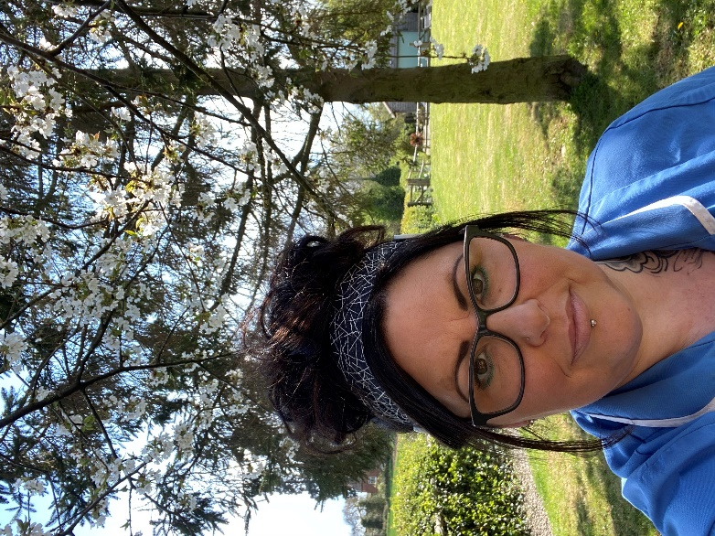
Clare Cowell-age 46- Care Assistant at
Bluebird Care (Worcester & Wychavon)
My story….
Being diagnosed with a permanently painful degenerative spinal condition 12 years ago, I understand that there comes a time when people need genuine, high quality care.
I started my journey in 2020, at the beginning of the Coronavirus Pandemic after sadly losing my dad to Covid-19.
I had cared for both of my parents over a 10-year period through various illnesses including Cancer, Sepsis and Alzheimer’s.
Feeling that I needed to continue that caring role in supporting others, I first became a Responder for the Royal Voluntary Service supporting vulnerable people in the community shielding from the virus.
I wanted to offer more. I applied for several care assistant positions but during my final interview, I knew I’d become a ‘Bluebird’. My journey to date has been difficult at times due to my condition. All of the team have shown me support, encouragement and guidance helping me achieve my goals as best I can.
There are no ‘typical days’ as they are varied. Certainly, it can be a difficult, hard and frustrating at times. Being a carer can make you laugh, cry and feel immensely proud (all in one day!) and I wouldn’t want to do anything else. The people I have met along the way, the stories customers and other carers have shared with me have been inspiring.
I couldn’t continue to care for others without the support from my amazing family- (my devoted husband, Dave and daughters; Kelsie and Aaliyah, including all the love and attention from our fostered and adopted animals we care for).
Knowing that I put my heart and soul into each visit, to hopefully make a difference to that person and their family members means the world to me……I’ve been known to say it once or twice, but it’s true –
I love my job!
So please, to the caring individuals out there who are apprehensive in taking the leap into the Care Sector, contact Bluebird Care Worcester & Wychavon, you’ll be a valued member of a great team taking on a hugely important role and you won’t be disappointed.
Thank you for taking time to read my story so far…

