
NEWSLETTER SUMMER 2025


Wow! Half way through the year already. I hope everyone is enjoying this lovely summer weather. If you can, its so lovely to get outside and let the skin soak up that Vitamin D.

TELL US WHAT YOU THINK

Attached to this newsletter is a paper copy of our 2025 customer survey and SAE for return. For those of you online, we have instead sent a Survey Monkey link. Please do share with us your feedback on the service we provide. It takes only a few minutes. What you tell us of your experience really does help us to understand what we do well and what we don’t and, most importantly, how we can improve. We’ve gone through this process every year and it really does make a difference.


NEWS
There have been good things happening in 2025:
Enhancing Dementia Care 
This Photo by Unknown Author is licensed under CC BY-NC-ND
We are committed to developing and enhancing how we support people living with dementia and their loved ones. To that end, we welcome our very own Helen Prady into a newly created post Dementia Care Lead. Many of you will already know Helen, who is a senior level carer, and has worked at Bluebird for 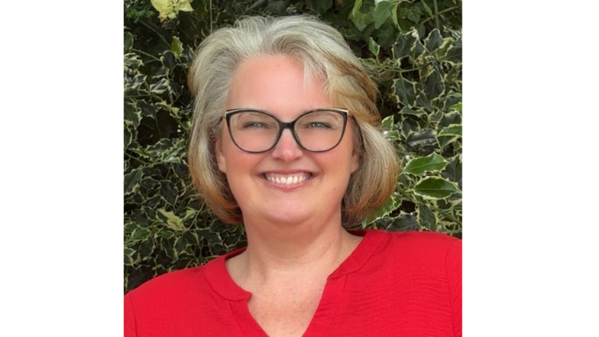
over 5 years. Helen has undertaken additional specialist training for her role and this is complemented by extensive professional experience both before and since joining Bluebird Care. Helen’s purpose is to ensure that each of our dementia customers receive a bespoke service tailored precisely to their requirements. Her role involves troubleshooting problems, identifying solutions, training and mentoring our field carers, and advocating for our dementia customers and their families in the community.
Helen has already spent time with a number of our customers and feedback has been really positive. She may well be in touch with you soon. But if you feel you or your loved one might benefit from Helen’s intervention or advice, then do please get in touch. There is no charge to this service and I strongly urge you to take advantage of it.

VE day 80 years
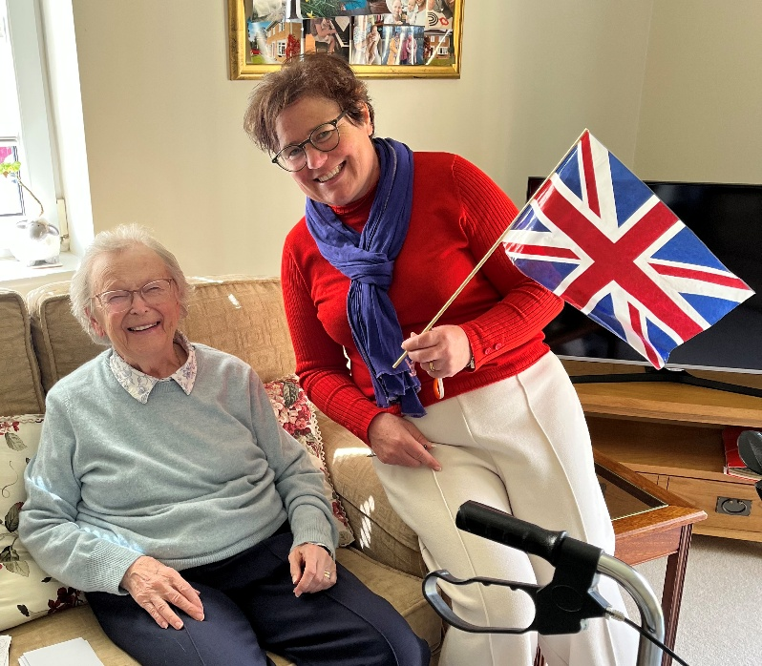 | 
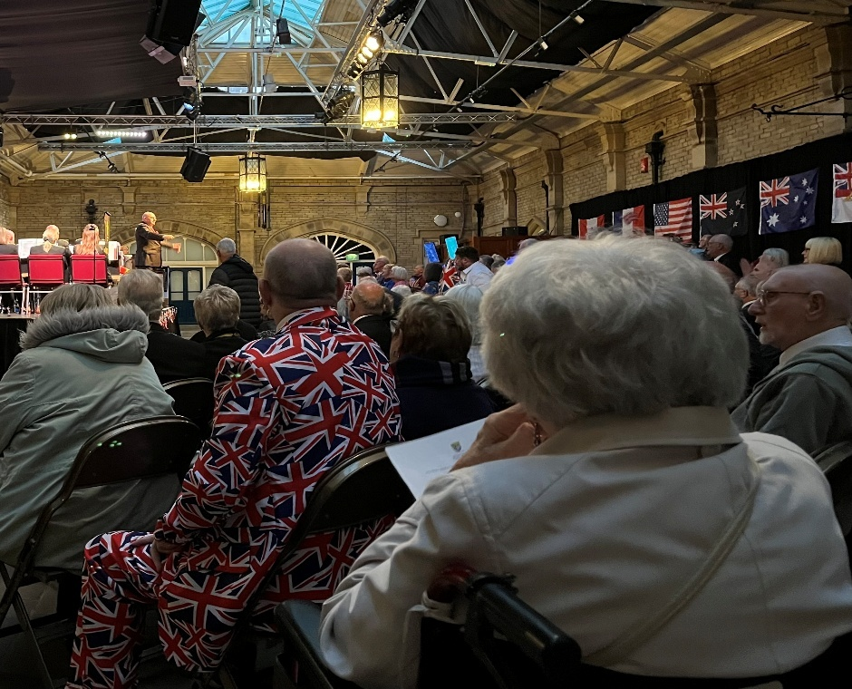

We hope you all enjoyed a slice of cake in May! There are many good reasons why we celebrate VE day, all generations have much to be grateful for. And 80 years anniversary required something extra special. Thank you to all the cake bakers (special shout out Suzanne S!) and the volunteers who helped with delivery.
We also managed to get some spare tickets from Morecambe Council for the special evening brass band Peace Concert at The Platform in Morecambe. Carer Cheryl accompanied Doreen W from Bowerham, who was 16 when the war ended. Doreen is 96 now and lives alone, only able to leave the house with assistance. Doreen said, “I had a wonderful time, it brought back so many memories. I feel so much more like a normal person when I get out and do things".

Celebrating Achievement

Angela Award
Every quarter we present the Angela Award to our team member who most excels in the following categories:
- Compassion in Care
- Working in a team
- Attitude to learning
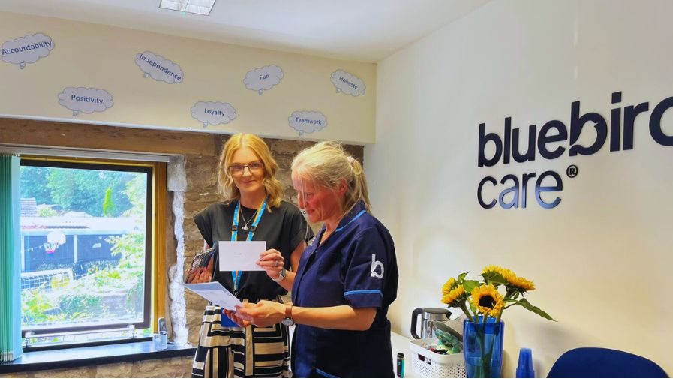
This time, it went to Suzanne Smith. Suzanne joined two years ago, new to care and very unsure. However, from the word go she demonstrated compassion towards her customers, their family members, and to her Bluebird colleagues. She took every care to overcome her anxieties and learn exactly what each of her customers needed. She is truly dedicated to their well-being and takes every care and attention at each visit. She is also always mindful of her role in a wider team: almost never absent; helping her colleagues at every opportunity and contributing to every extra-curricular occasion. And if cakes need baking, Suzanne gets her pinny on in a flash! When she started, Suzanne really struggled to take on board our extensive training programme. But in recent months she has raced through her national vocational qualification level 2 in health and social care at record speed. We are hugely grateful to her for the amazing contribution she makes.
Suzanne says, "I really enjoy my job, I was nervous to begin with, but now its just a joy. And I'm really chuffed to receive this award."
Previous Angela Award winner in 2025 was live-in carer Audrey Lampty, whose work this year has been truly OUTSTANDING.

Carers of the Month 2025
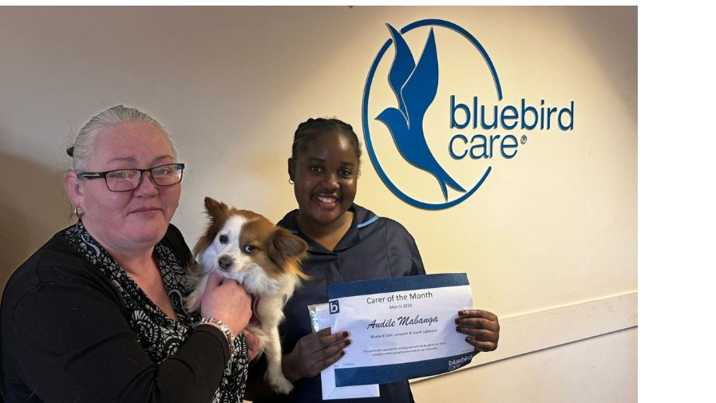
- January: Desi
- February: Fiona
- March: Andi
- April: Samantha (live-in)

We welcome your nominations for Carer of the Month and Angela Award. We would love to receive more nominations from our customers, other professionals and family members. Jut call or email the office. It all helps to ensure we make the right choices

Staff News
Our live-in care expert, Heather Harley will be swimming half a mile in Ullswater on Saturday 28th June to raise funds for and awareness of arthritis. Heather lives with this condition herself. It also affects a good number of our customers. Great effort, Heather.
Sinead Bousfield is returning – with gusto - to work after maternity leave. She now has two handsome boys to bring up!
The wonderful Prince has had to return to Zimbabwe for personal reasons. We miss him terribly.
Welcome and good luck to new team members: Tino, Capri and Gupreet.
We say good bye to Janine after a fantastic 7 years career with us and many accolades. We also say goodbye to Carmen, who has a new job in the motor sector and to Lindsey Bellamy.


FUNDRAISING FOR CANCERCARE

We are delighted to have chosen CancerCare as our charity for 2025. Local and independent it's dedicated to helping adults and children affected by cancer or bereavement in North Lancashire and South Cumbria. More than 90% of CancerCare's funding comes from donations so that they can continue to offer their services for free. Most of us who live around here knows someone who has benefitted from CancerCare's wonderful services.
The story so far…….
WALK 100 MILES Throughout February, 6 dog-owners from Bluebird walked 100 miles each. Finn the dog shared his time between Claire and David. Congrats to all for helping us raise £190.

CANCERCARE'S VERSION OF THE TRAITORS Recruitment and Training Manager Steph is representing us at CancerCare's "The Betrayers" in October. Wearing a cape at all times, she will be navigating challenges and mind games against other local businesses. She's already started her fundraising, so pitch in and donate, OR ELSE!!!
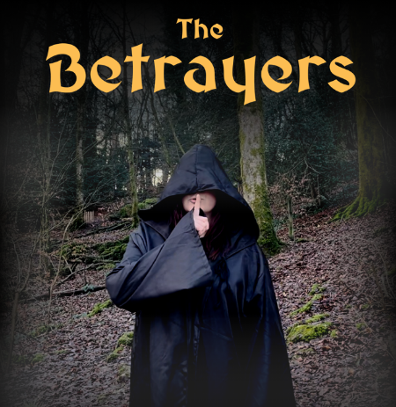

CONISTON TO BARROW WALK
Led by our Registered Manager Alyson Hartlebury, 5 intrepid members of the Bluebird team marched with thousands of others through the Lake District on 11th May as part of the famous annual “K2B” event, just about making it to the end although not necessarily in one piece......... What a day!
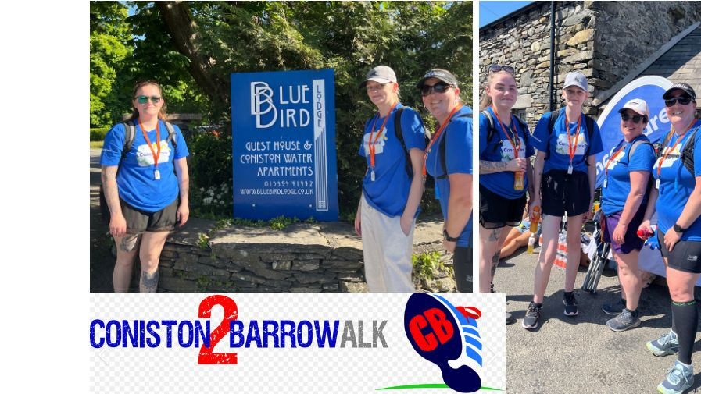
Alyson, Claire, Jana and Rachel completed the shorter 20 mile version from Coniston to Barrow - through England's most beautiful scenery and in glorious sunshine. Between us, we raised over £1300 for CancerCare - a fantastic effort.
There were blisters and cramps, tears and trauma, good times and bad. But throughout, there was sunshine, smiles and gritty determination to keep pushing through. We started at Coniston, walking all along the east of lake and turning up into the Dalton hills and finally down into Barrow, surrounded at all times by banana-bearing well-wishers and stunning countryside
We walked in the shadows of our heroic "Bluebird" forebear Donald Campbell, who attempted the world water speed record on Coniston Water back in the 70s in the aquatic member of his "Bluebird" fleet. We even passed "The Bluebird Lodge" en route. It felt personal.....
For some of us, this was the most mentally and physically challenging thing we have done, for others we had deeply personal reasons for doing it. But we all prevailed and made it to the end in 8hrs 45 mins.
Our very own Rebecca Blackstone, meanwhile, also took part, but as an individual raising funds for St Johns Hospice. A true champion, Rebecca did the full 40 miles from Keswick to Barrow. At the end she was rather tired and said, "That was a silly idea really, what was I thinking?! I'm a mess!"

WHO’S WHO

We work as a team, but here’s a reminder of who does what:
Alyson Hartlebury – Registered Manager. Overall responsibility for delivery of a safe and effective service. Big Boss Lady. Her door is always open
Nicola Dryden – Coordinator and Domiciliary Care Manager. Contact Nicola directly on anything regarding your schedule – allocated carers, timings etc.
Toni Farrer – your first point of liaison on any aspect of the service we provide and changes you would like to make. Toni ensures we review and update your care plans regularly
Jana Cayeux - leads on and the management of medications all matters live-in care
Ritika Tyagi – Lead Supervisor. Monitors, manages and supports our senior carers and all domiciliary care assistants
Steph Anderson – Recruitment and Training
Helen Prady – Dementia Care Lead
Cheryl Prouse and Camila Cardenas our new senior carers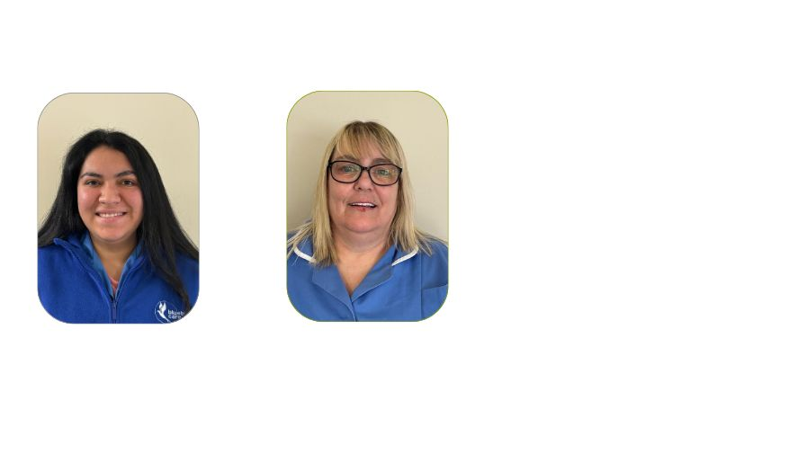
Finn and Betty – our canine team, always ready to go visiting our customers. Let us know if you’d like to see either of them.
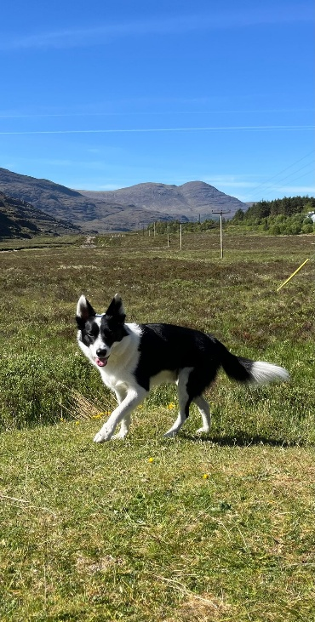
Best wishes everyone…….

